

## UNIVERSITY OF CENTRAL PUNJAB

**FACULTY OF INFORMATION TECHNOLOGY**

**DEPARTMENT OF COMPUTER SCIENCE**

**LAB MANUAL**

**CP101: Introduction to Computing - Lab**

**Instructor Name: Asma**

**Lab 01: Introduction to Microsoft Word**

**Objective**

* To introduce the importance of MS. Word.
* To make an effective lab report.
* Use of tables, graphs, equations and symbols etc.
* How to protect documents.

**Introduction**

Microsoft word is a word processor software developed by Microsoft in 1983. It is the most commonly used word processor software. It is used to create professional quality documents, letters, reports, resumes, etc and also allows you to edit or modify your new or existing document. The file saved in Ms Word has .docx extension.

### Starting Microsoft Word

1. Type Ms Word in the search bar.
2. Select Ms Word application



1. Select Blank Document from the options.

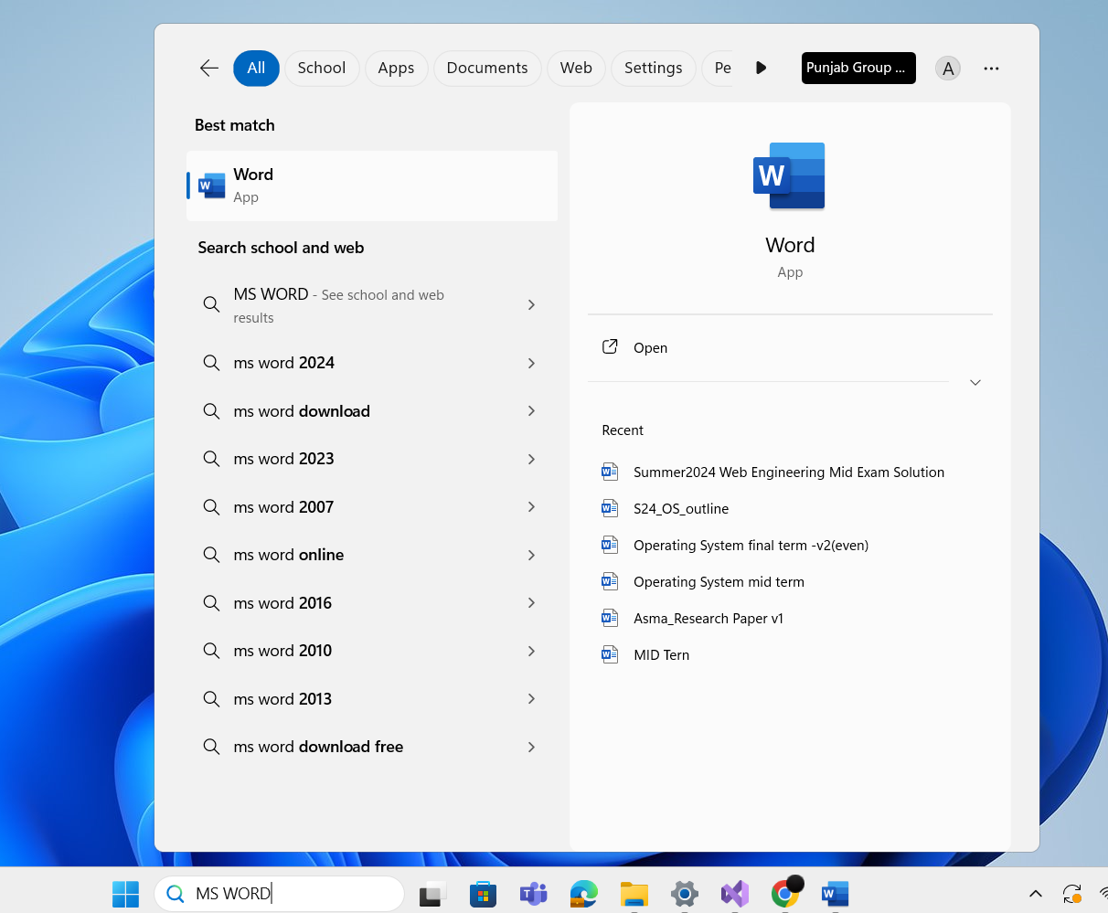



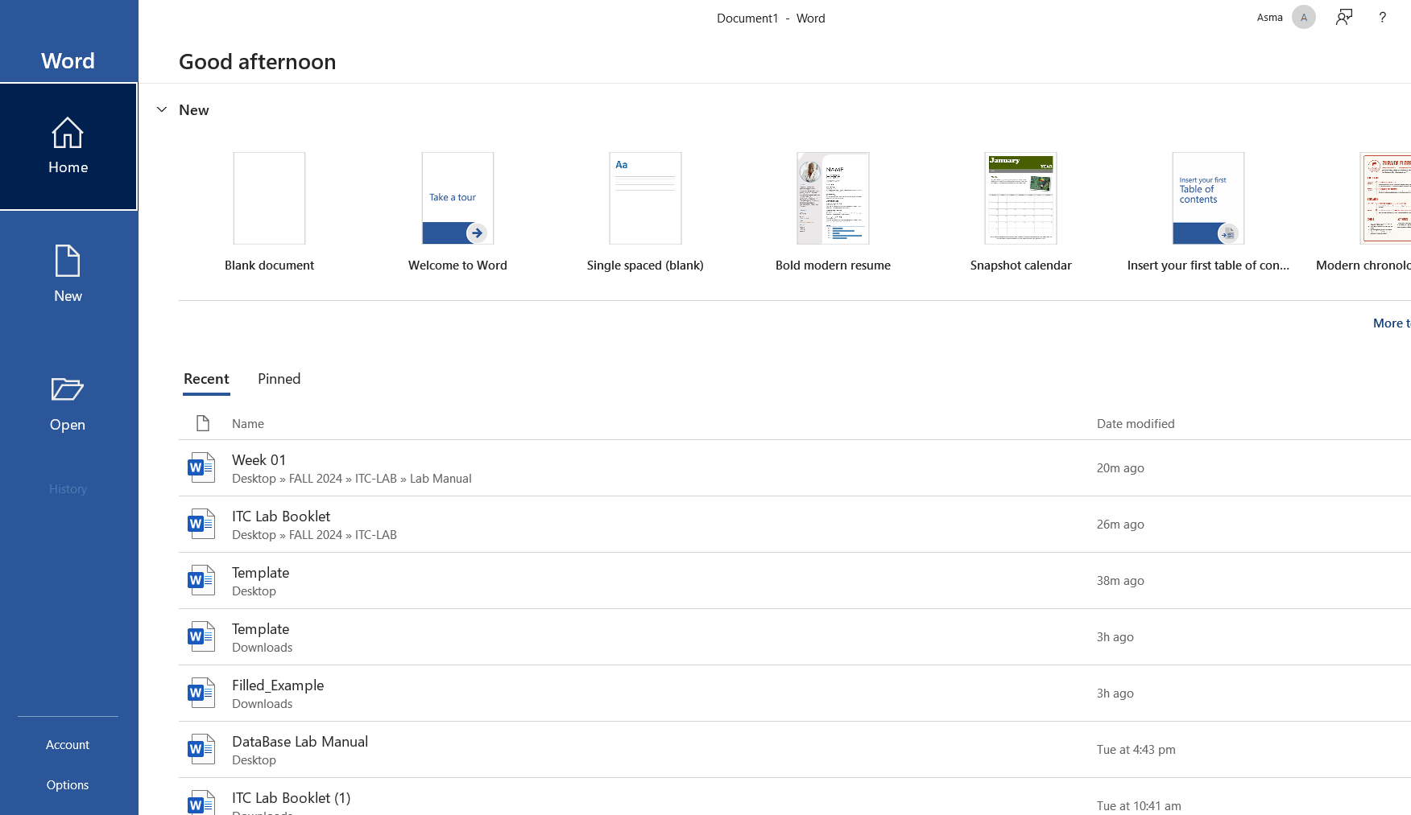



## Opening a Document

In addition to creating new documents, you'll often need to open a document that was previously saved.

1. Navigate to **Backstage view**, then click **Open**.
2. 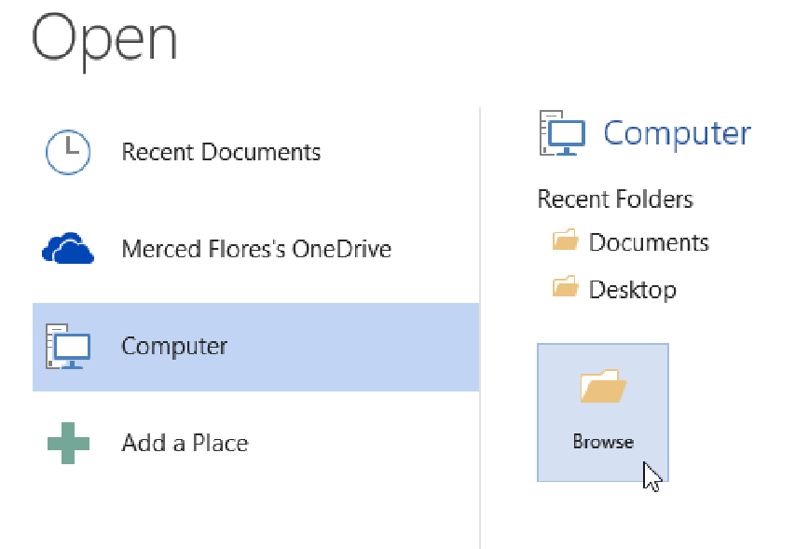Select **Computer** and then click **Browse**. Alternatively, you can choose **OneDrive** (previously known as SkyDrive) to open files stored on your OneDrive.
3. The **Open** dialog box appears. Locate and select your **document**, then click **Open**.

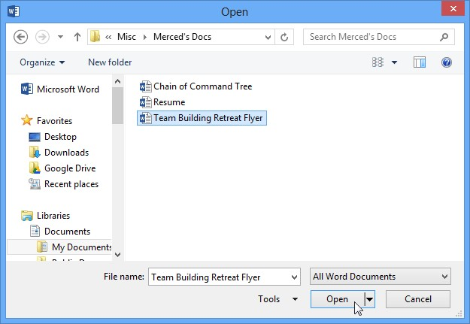

## Working with Templates

A **template** is a **predesigned document** you can use to create a new document quickly. Templates often include **custom formatting** and **designs**, so they can save you a lot of time and effort when starting a new project.

To create a new document from a template:

1. Click the **File** tab to access **Backstage view**.

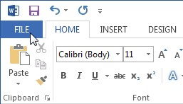

1. Select **New**. Several templates will appear below the **Blank document** option.
2. Select a **template** to review it.

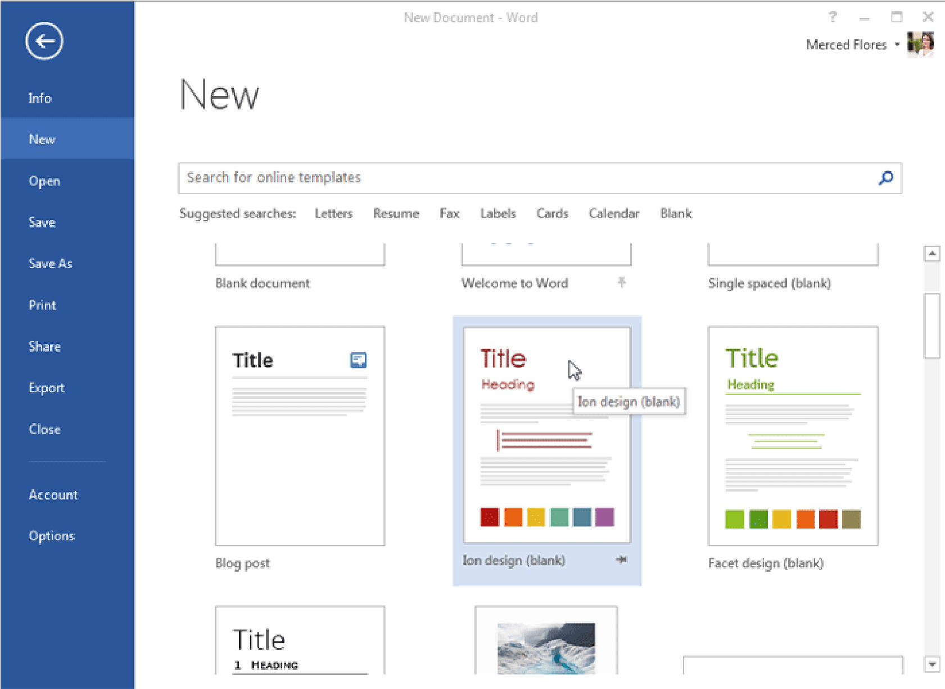

1. A **preview** of the template will appear, along with **additional information** about how the template can be used.
2. Click **Create** to use the selected template.

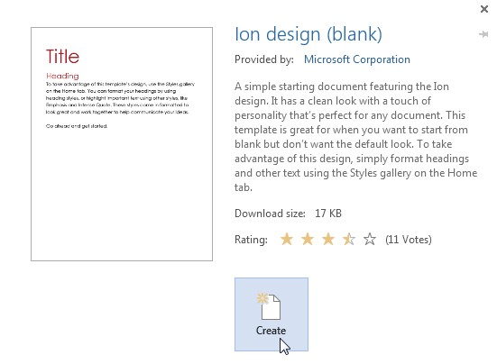

1. A new workbook will appear with the **selected template**.

# Text Basics

If you're new to Microsoft Word, you'll need to learn the **basics of working with text** so you can type, reorganize, and edit text. Basic tasks include the ability to **add**, **delete**, and **move text**, as well as the ability to **find and replace** specific words or phrases. **Using the insertion point to add text**

The **insertion point** is the blinking vertical line in your document. It indicates where you can enter **text** on the page. You can use the insertion point in a variety of ways:

* **Blank document:** When a new blank document opens, the insertion point is located in the top left corner of the page. If you wish, you can begin typing from this location.

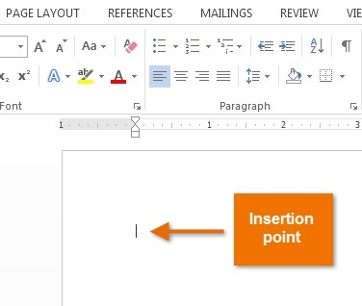

* **Adding spaces:** Press the **space bar** to add **spaces** after a word or in between text.
* **New paragraph line:** Press **Enter** on your keyboard to move the insertion point to the next paragraph line.
* **Manual placement:** After you've started typing, you can use the mouse to move the insertion point to a specific place in your document. Simply click the **location** in the text where you wish to place it.

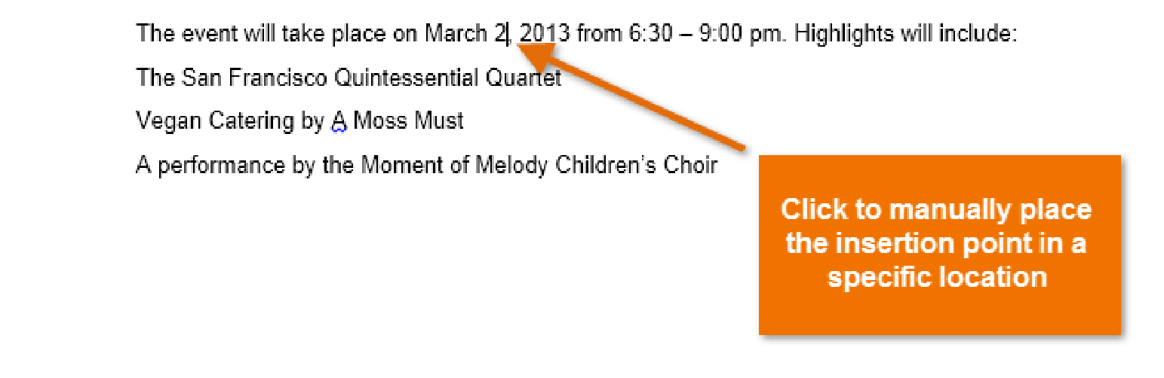

In a new blank document, you can double-click the mouse to move the insertion point elsewhere on the page.

## To select text:

Before applying formatting to text, you'll first need to **select** it.

1. Place the **insertion point** next to the text you wish to select.
2. Click the mouse, and while holding it down drag your mouse over the text to select it.
3. Release the mouse button. You have selected the text. A **highlighted box** will appear over the selected text.

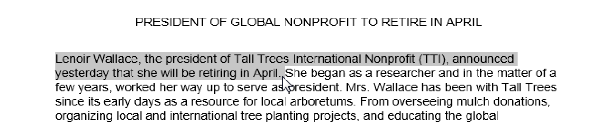

When you select text or images in Word, a **hover toolbar** with command shortcuts appears. If the toolbar does not appear at first, try moving the mouse over the selection.

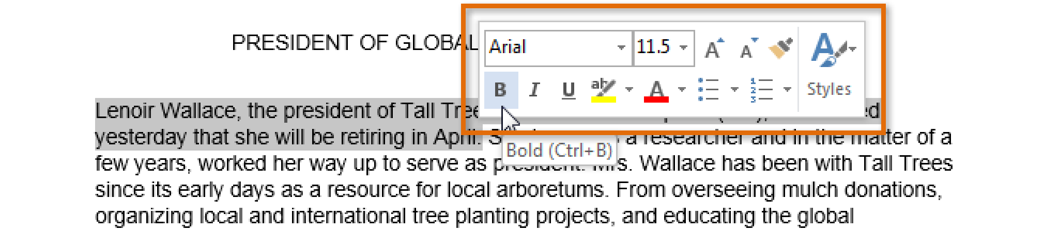

Other shortcuts include double-clicking a word to select it and triple-clicking to select a sentence or paragraph. You can also select all of the text in the document by pressing **Ctrl+A** on your keyboard.

## To delete text:

There are several ways to **delete**, or remove, text:

* To delete text to the **left** of the insertion point, press the **Backspace** key on your keyboard.
* To delete text to the **right** of the insertion point, press the **Delete** key on your keyboard.
* Select the **text** that you wish to remove, then press the **Delete** key.

## Copying & Pasting Text

Word allows you to **copy** text that is already in your document and **paste** it to other areas of the document, which can save you time. If there is text that you wish to move from one area of the document to another, you can **cut and paste** or **drag and drop** the text.

**To copy and paste text:**

Copying text creates a **duplicate** of the text.

1. Select the **text** you wish to copy.

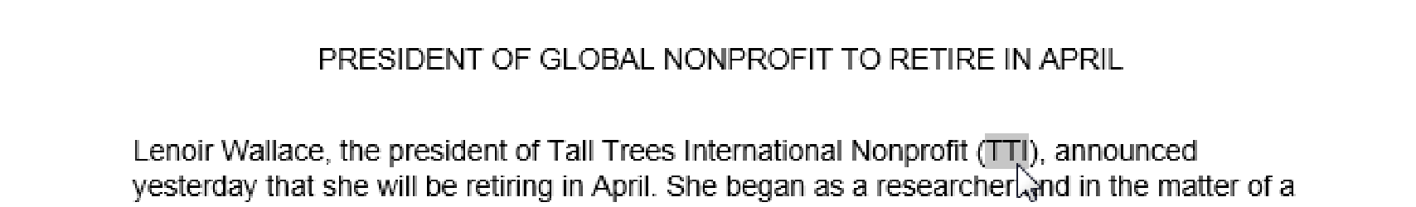

1. Click the **Copy** command on the **Home** tab. You can also right-click the selected text and

select

**Copy**

.

3.

Place the inserti

on point where you wish the text to appear.

4.

Click the

**Paste**

command on the Home tab.

5.

The text will appear.

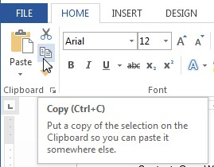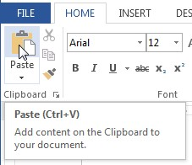

## To cut and paste text:

1.

Select the

**text**

you wish to cut.

2.

Click the

**Cut**

command on the

**Home**

tab. You can also right

-

click the

selected text

and select

**Cut**

.

3.

Place your insertion point where you wish the text to appear.

4.

Click the

**Paste**

command on the

**Home**

tab. The text will appear.

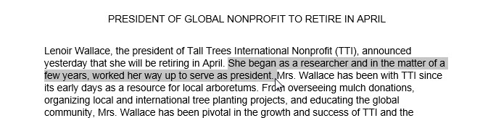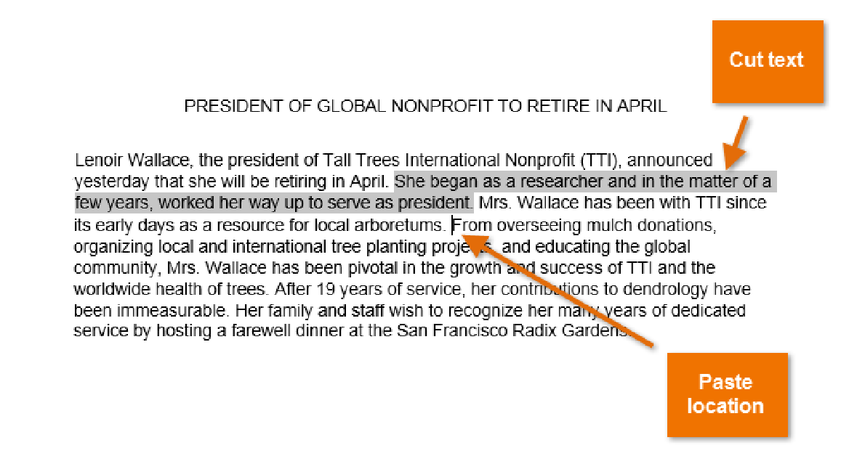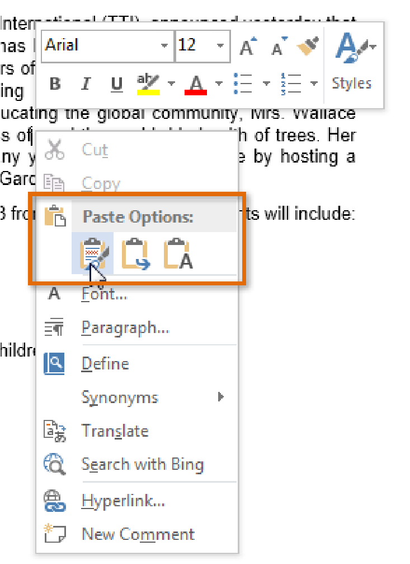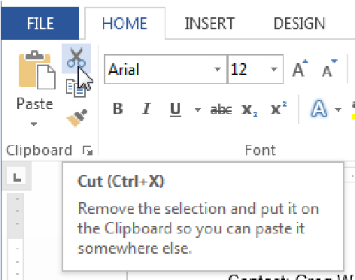

*You can access the cut, copy, and paste commands by using keyboard shortcuts. Press **Ctrl+X** to cut,**Ctrl+C** to copy, and **Ctrl+V** to paste.

You can also cut, copy, and paste by right-clicking your document and choosing the desired action from the drop-down menu. When you use this method to paste, you can choose from three options that determine how the text will be formatted: **Keep Source Formatting**, **Merge Formatting**, and **Keep Text Only**. You can hover the mouse over each icon to see what it will look like before you click on it.

# Formatting Text

**Formatted text** can draw the reader's attention to specific parts of a document and emphasize important information. In Word, you have many options for adjusting the **font** of your text, including **size**, **color**, and inserting special **symbols**. You can also adjust the **alignment** of the text to change how it is displayed on the page. **To change the font:**

By default, the font of each new document is set to Calibri. However, Word provides a variety of other fonts you can use to customize text and titles.

1. Select the text you wish to modify.
2. On the **Home** tab, click the **drop-down arrow** next to the **Font** box. A menu of font styles will appear.
3. Move the mouse over the various font styles. A live preview of the font will appear in the

document. Select the font style you wish to use.

4.

The font will change in the document

**To change the font size:**

1.

Select the text you wish to modify.

2.

Select the desired font size formatting option:

o

**Font size drop**

**-**

**down arrow:**

On

the

**Home**

tab, click the Font size drop

-

down

arrow. A menu of font sizes will appear. When

you move the mouse over the various font

sizes, a li

ve preview of the font size will

appear in the document.

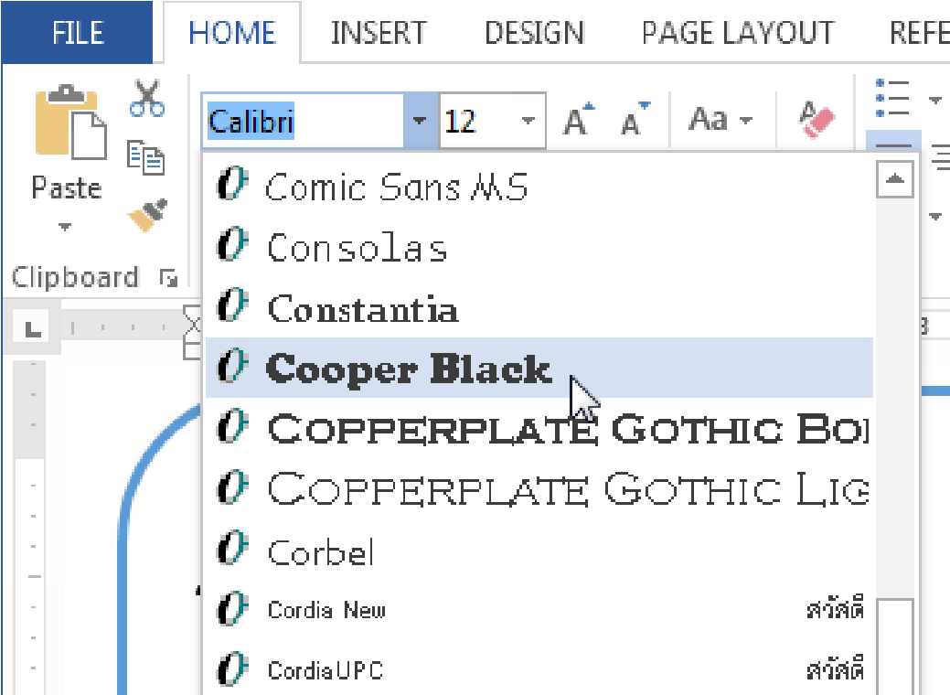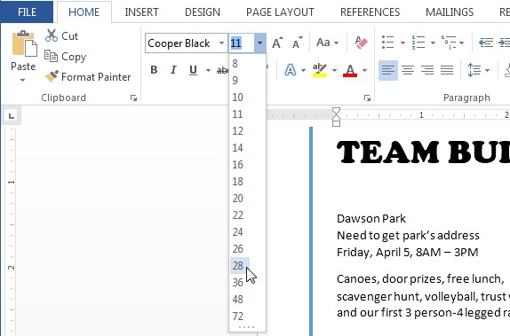

* + **Font size box:** When the font size you need is not available in the Font size drop-down arrow, you can click the Font size box and **type** the desired font size. Then press **Enter**.

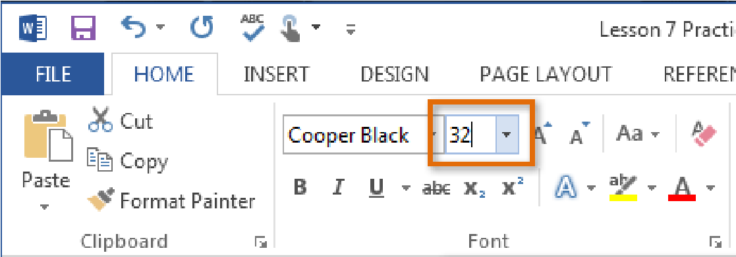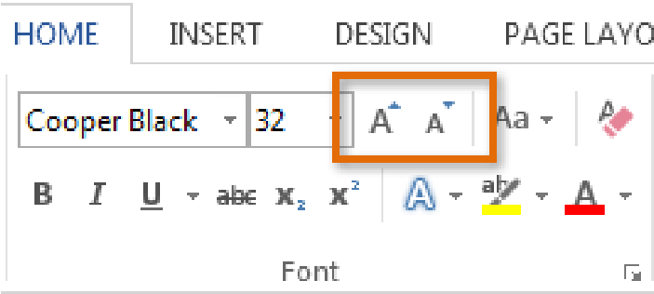

* + **Grow and shrink font commands:** Click the **Grow Font** or **Shrink Font** commands to change the font size.

3. The font size will change in the document.

## To change the font color:

1. Select the text you wish to modify.
2. On the **Home** tab, click the **Font Color** drop-down arrow. The **Font Color** menu appears.
3. Move the mouse over the various font colors. A live preview of the color will appear in the document.

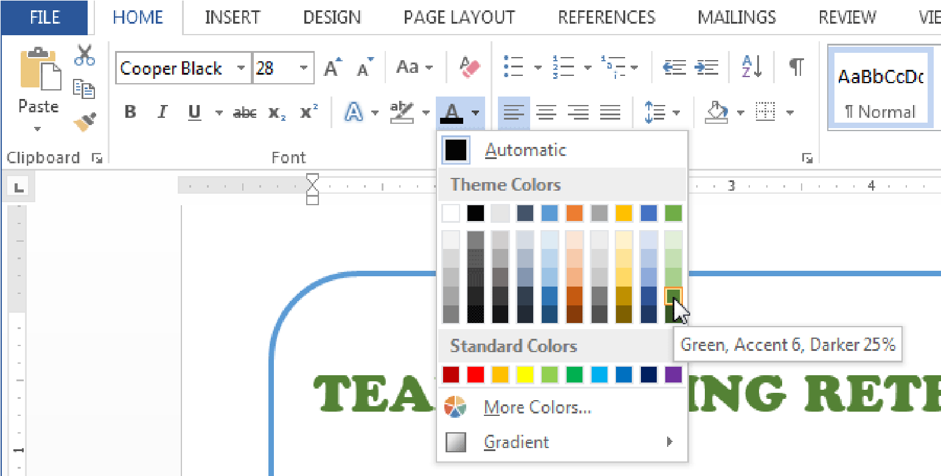

1. Select the font color you wish to use. The font color will change in the document.

Your color choices aren't limited to the drop-down menu that appears. Select **More Colors...** at the bottom of the menu to access the **Colors** dialog box. Choose the color that you want, then click **OK**.

# Working with Paragraphs

## Changing Alignment

By default, Word aligns text to the **left margin** in new documents. However, there may be times when you want to adjust text alignment to the center or right.

1. Select the text you wish to modify.
2. On the **Home** tab, select one of the four **alignment options** from the **Paragraph** group.

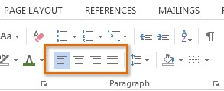

## Line Spacing

As you design your document and make formatting decisions, you will need to consider **line** and **paragraph spacing**. You can **increase** spacing to improve readability or **reduce** it to fit more text on the page.

**About line spacing**

Line spacing is the **space between each line** in a paragraph. Microsoft Word allows you to customize the line spacing to be **single-spaced** (one line high), **double-spaced** (two lines high), or any other amount you want. The default spacing in Word 2013 is **1.08 lines**, which is slightly larger than singlespaced.

**To format line spacing:**

1. Select the text you wish to format.
2. On the **Home** tab, click the **Line and Paragraph Spacing** command. A drop-down menu will appear.
3. Move the mouse over the various options. A live preview of the line spacing will appear in the document. Select the line spacing you wish to use.

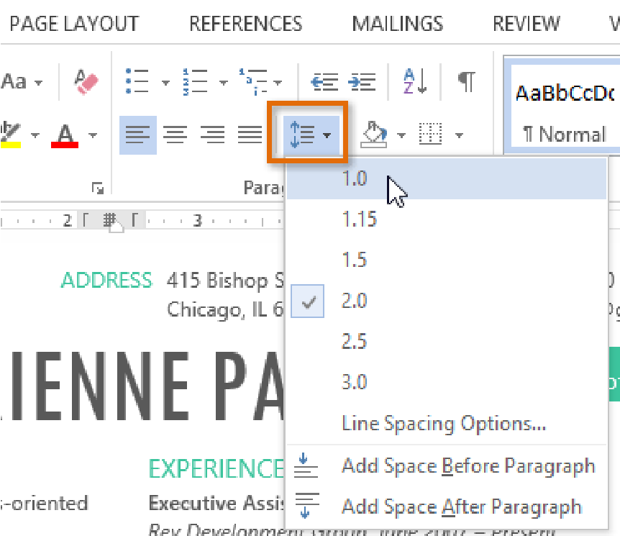

1. The line spacing will change in the document.

**Fine-tuning line spacing**

Your line spacing options aren't limited to the ones in the **Line and Paragraph Spacing** menu. To adjust the spacing with more precision, select **Line Spacing Options** from the menu to access the **Paragraph** dialog box. You'll then have a few additional options you can use to customize the spacing:

* **Exactly:**

When you choose this option, the line spacing is **measured in points**, just like font sizes. Generally, the spacing should be slightly larger than the font size. For example, if you're using **12-point** text, you could use**15-point** spacing.

* **At least:**

Like the **Exactly** option, this option lets you choose how many points of spacing you want. However, if you have different sizes of text on the same line, the spacing will expand to fit the larger text.

* **Multiple:**

This option lets you type in the number of lines of spacing you want. For example, choosing **Multiple** and changing the spacing to **1.2** will make the text a little more spread out than single-spaced text. If you want the lines to be closer together, you can choose a smaller value like **0.9**.

## Bulleted & Numbered Lists

Bulleted and numbered lists can be used in your documents to outline, arrange, and emphasize text. In this lesson, you will learn how to **modify existing bullets**, insert new **bulleted** and **numbered lists**, select **symbols** as bullets, and format **multilevel lists**.

**To create a bulleted list:**

1. Select the text you wish to format as a list.

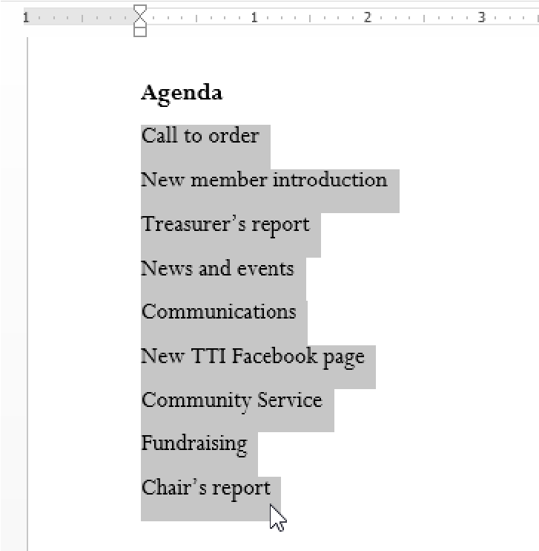

1. On the **Home** tab, click the **drop-down arrow** next to the **Bullets** command. A menu of bullet styles will appear.

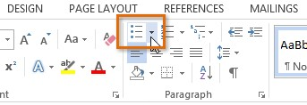

1. Move the mouse over the various bullet styles. A live preview of the bullet style will appear in the document. Select the bullet style you wish to use.

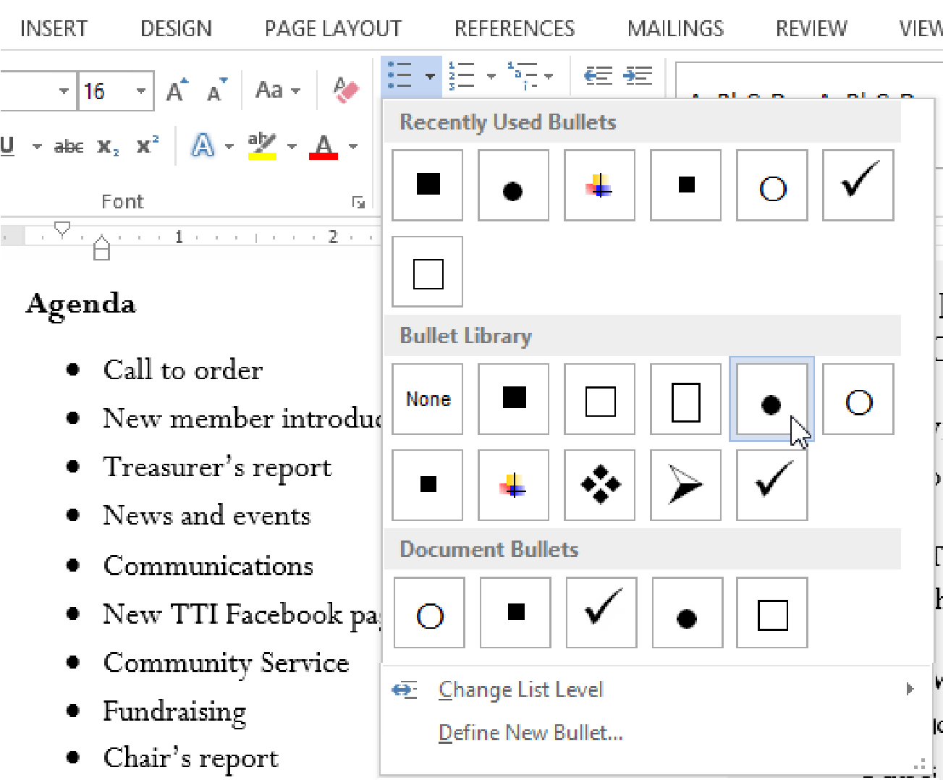

1. The text will be formatted as a bulleted list.

**To create a numbered list:**

When you need to organize text into a **numbered** list, Word offers several **numbering** options. You can format your list with **numbers**, **letters**, or **Roman numerals**.

1. Select the text you wish to format as a list.
2. On the **Home** tab, click the **drop-down arrow** next to the **Numbering** command. A menu of numbering styles will appear.

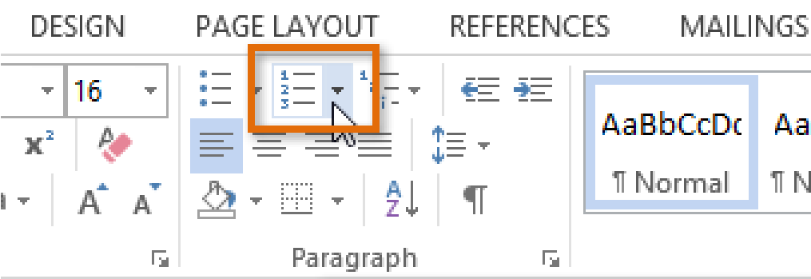

1. Move the mouse over the various numbering styles. A live preview of the numbering style will appear in the document. Select the numbering style you wish to use.

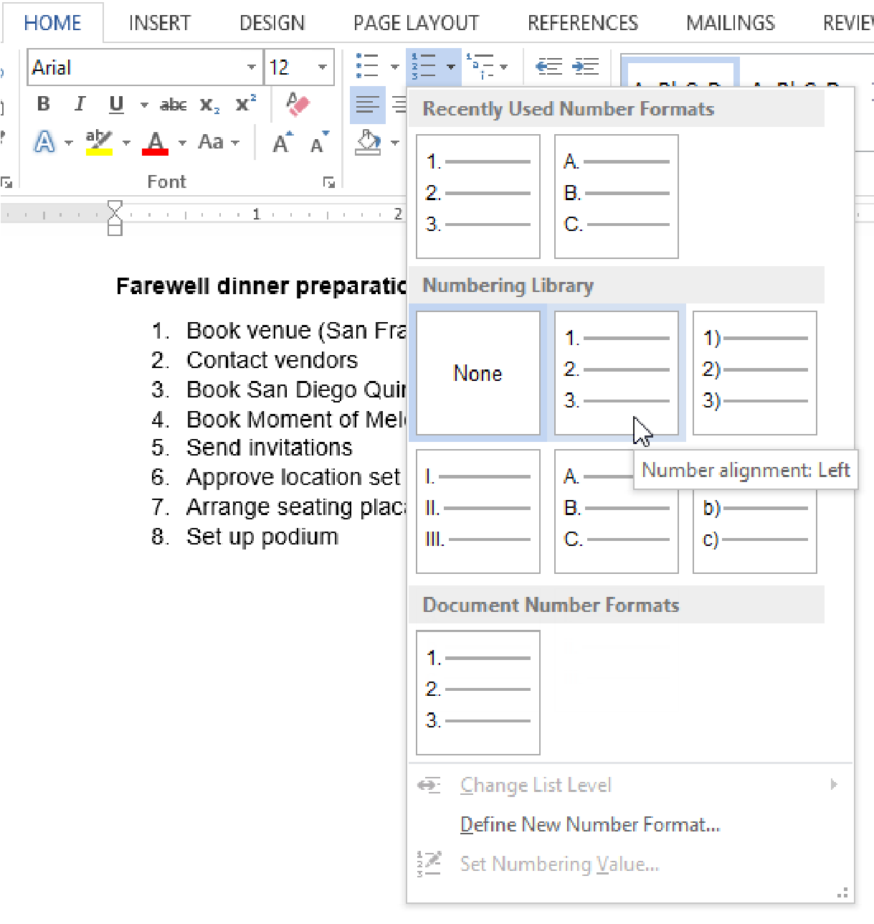

1. The text will format as a numbered list.

**Keyboard Shortcuts**

* CTRL + S = Save
* CTRL + P = Print
* CTRL + C = Copy
* CTRL + V = Paste
* CTRL + Z = Undo
* CTRL + Y = Redo
* CTRL + F = Find

1. **Review and View**

The Review tab is used to review a paper. The tools that we will discuss from this tab are Track changes, review pane, comments, accept and reject and protect document. View tab is used for zoom, hide and show gridlines, rulers etc.

**Lab Task:** Write equations inside the table as shown below.

|  |  |
| --- | --- |
| **S/no.** | **Equation** |
| 1 |  |
| 2 |  |
| 3 |  |